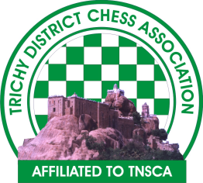
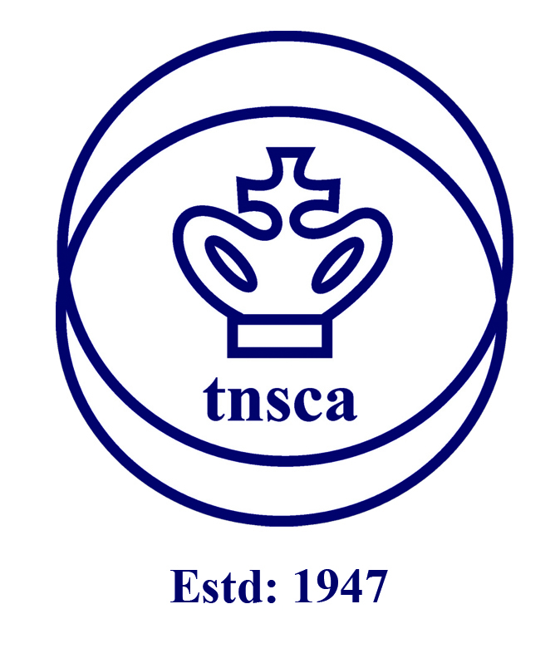

Pothys NECT 1st State Level Children& Open Chess Tournament
(TNSCA Approval No :CO-37/TRY/23-24)
OrganisedBy:Nedunchezhian Educational & Charitable Trust
Date :29.07.2023 (Saturday)
Venue :St Joseph College, Chathiram Bus Stand, Trichy

Entry Fee: Rs.300

Total Cash Prize : ₹ 15,000 (15 Cash Prizes)

Prize Money Breakup :

1st - ₹ 4000 6th - ₹ 650 11th - ₹ 300
2nd - ₹ 3000 7th - ₹ 600 12th - ₹ 300
3rd - ₹ 2000 8th - ₹ 500 13th - ₹ 300
4th - ₹ 1000 9th - ₹ 500 14th - ₹ 300
5th - ₹ 750 10th - ₹ 500 15th - ₹ 300
Prizes for Categories:
U- 07 Boys 15 Prizes (10 Trophies + 5 Medals) U-07 Girls15 Prizes (10 Trophies + 5 Medals)
U-10 Boys15 Prizes (10 Trophies + 5 Medals) U-10 Girls15 Prizes (10 Trophies + 5 Medals)
U-13 Boys 15 Prizes (10 Trophies + 5 Medals) U-13Girls15 Prizes (10 Trophies + 5 Medals)
U-18 Boys15 Prizes (10 Trophies + 5 Medals) U-18 Girls15 Prizes (10 Trophies + 5 Medals)
Entry Fee : Rs. 300/- per player can be sent by DD/ Cheque in Favour of OrganisationName :Nedunchezhian Educational & Charitable Trust payable at CUB Srirangamto Organiser AddressNo 4 NJ Apartments Ammamandapam Road, Srirangam

Last Date : before 3 days(complete days) 25/07/2023 @ 18.00
Rules and Regulations
- The Tournament is open to Tamil Nadu Players only.
- The Latest FIDE Rules in force shall apply and the Swiss system will be followed.
- Time Control: 25 Minutes Each
- The first round will commence at 09.00 AM on 29.07.2023 The number of rounds and the round-wise schedule will be announced at the tournament venue.
- Players are requested to bring their own international chess sets (and chess clock if, any).
- Tiebreak: Buchholz tiebreak system will be applied. In case of a tie, prizes will not be shared.
- The Chief Arbiter's' decisions' shall be final and binding on all players concerned.
- Age proof Certificate must be produced for Children’s category prizes.
- Entries close at 06.00 P.M on 25.07.2023 No entry will be entertained after 6 P.M on 25.07.2023. Strictly no Spot Entries.
- TNSCA player registration is compulsory for all players. TNSCA player registration fee is Rs.150/- for the year 2023 – 2024. Players registering with TNSCA should submit duly filled and signed TNSCA Players Registration form along with a copy of their Date of Birth certificate and one passport-size photograph.
- Trichy DCA Registration fee is Rs.75/- for the year 2023 – 2024 (for Trichy district players only)
- The TNSCA /TDCA / organizerNedununchezhian Educational & Charitable Trustreserves the rights of admission to the venue and lodging place.
- Participation certificates will be awarded to all participants.
- Age Limit
Under –07 Born on or After 01.01.2016
Under – 10 Born on or After 01.01.2013
Under – 13 Born on or After 01.01.2010
Under – 18 Born on or After 01.01.2005
& OPEN (No age limit)
Contact Details:OrganisationName :Nedunchezhian Educational & Charitable Trust
Organizer Name :Sripriya V (Secretary - Nedunchezhian Educational & Charitable Trust)
Address: No 4 NJ Apartments Ammamandapam Road, Srirangam
Cell :8778667028
E-Mail: nect102021@gmail.com

